 | About Grease Removal Devices (GRD’s)… |  |  |  |  |  | 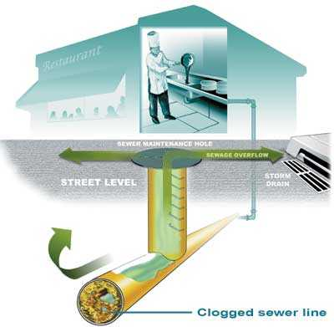  Food Service Establishments (FSE’s)  How to Save Money  and  Protect the Environment  West County Wastewater  Water Quality & Resource Recovery Plant  2377 Garden Tract Road, Richmond CA 94801  Visit us at www.wcwd.org
 | Grease Removal Devices (GRD) should be designed and installed in accordance with the Uniform Plumbing Code, and the International Association of Plumbing and Mechanical Officials (IAPMO). Be sure to contact the WCW’s Engineering Department for information.  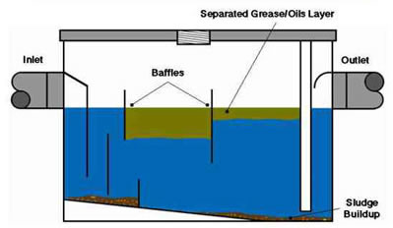  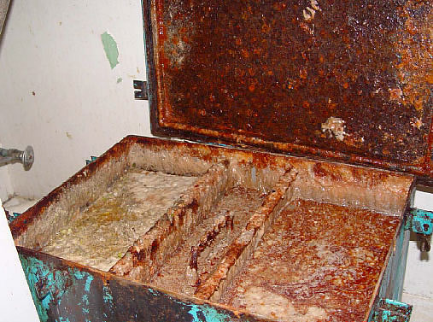  Garbage disposals should not be used because food waste will fill a GRD with solids, resulting in increased pumping frequency and higher maintenance costs. Install strainers on sinks, dishwashers and floor drains to prevent solids from entering the GRD. Educate kitchen staff to not remove drain screens. Captured food solids can be recycled or disposed of as food or solid waste. GRDs and good grease management practices are still required if you have a septic tank  or cesspool.  Be sure your equipment is regularly maintained and cleaned. |  | Keep records of (1) when and how much used oil is collected, (2) when GRDs are inspected, (3) when and who cleaned the GRD, (4) how much solids was removed from the GRD, and (5) where the solids from the GRD was taken.  All potential grease-carrying drains should connect to the GRD—including mop sinks, woks, wash sinks, prep sinks, utility sinks, pulpers, dishwashers, pre-rinse sinks, can washes, and floor drains in food prep areas.  Some technologies or “miracle cures” don’t eliminate the problem-they just result in grease building up further down the sewer line. Emulsifying agents (i.e, chemicals or soaps) are prohibited for use as an GRD additive or treatment.  Look in your black folder for the Grease Hauler List and talk to a certified waste hauler about how to properly manage your GRD, which will also help to save you money. Be sure the company has the proper permits to provide this service and periodically verify the company’s permit status.  By doing your part you help to protect the environment you will save money and help keep our water clean!!
Public Enemy Number One—FOG!! |  |  |  |  |  | When Cooking with Grease and Oil….  Strain or filter oil in deep fryers to extend the life of the cooking oil.  Control the temperature of deep fryers to prevent oil from scorching and extend its life. The less FOG in the trap or interceptor means $$ saved in cleaning and new oil purchased!  Remember that grease and oil can be valuable to others; they can be recycled into other valuable products. See the internet for “Grease Traps” or “Greases.”  Easy does it! Instruct staff to be conservative about the use of FOG in food preparation.  Keep FOG and Food Waste OUT of the Drain….  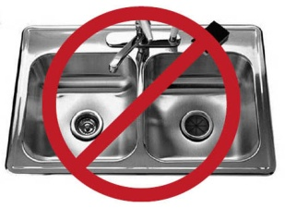  Recycle food waste. Don’t use garbage disposals to grind up food and flush it  down the drain.  Use dry cleanup to reduce water consumption, sewer use and save money! Remove food waste by scraping, wiping or sweeping before using wet methods that use water. Use rubber scrapers to remove FOG from cookware.  Use absorbent paper to soak up FOG under fryer baskets.  Use paper towels to wipe down work areas. Cloth towels will  accumulate grease that ends up in the drains from washing.  Minimize the use of dish soap in dishwashing operations. Dish soap emulsifies FOG and enables it to pass through a grease trap or interceptor, and build up in the sewer lines.  Dump your cooking oils and leftover grease into a storage container—like a barrel instead of down the drain. By managing it this way you can recycle it and reduce the cleaning frequency of the trap or interceptor.
Fats, Oils and Grease—known collectively as FOG — are a serious problem for public sewer lines. When FOG is disposed of or washed down the drain, it goes straight into our sewers and forms large, thick grease balls that can clog pipes.  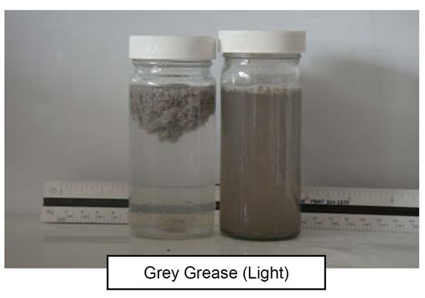  Clogged pipes can result in spills, creating environmental problems, traffic tie-ups, and even flooded businesses.  Commercial food handling facilities contribute greatly to FOG build-up in our sewer lines because of the amount of oil and grease used in cooking and other food prep work. We need your help to keep our environment clean and beautiful.  This is why we require that Food Service Establishments (FSE’s) and commercial facilities that prepare and/or serve food, install an appropriately sized grease removal device (GRD) — to stop the FOG before it reaches our sewer lines! If you do not have a GRD in place, please contact our office immediately so we can evaluate your GRD requirements. |  | Past grease control regulations for commercial food handling facilities did not sufficiently prevent grease from clogging the lines and causing sewage spills, so the U.S. EPA implemented measures to improve the situation. In order to comply with these measures FOG Control Programs are implemented; one of the most significant changes was the establishment of sizing criteria for grease removal devices and the requirement for their installation.  Contact the Environmental Programs Division at (510) 237-6603 for information on requirements for businesses, or visit our web site at www. wcwd.org for more information.  In the meantime, here are some tips to help keep our environment clean, and that can help you save money!  Fats, Oils and Grease—known collectively as FOG… FOG is a serious problem for public sewer lines.

